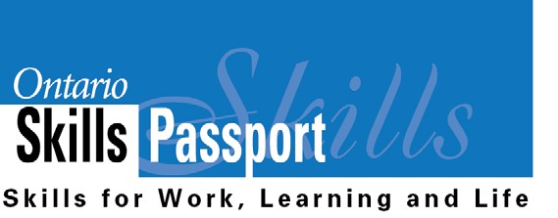
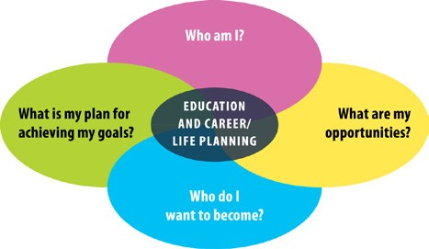
Ideas for Introducing Learners to Essential Skills and Work Habits in
Kindergarten to Grade 6

This resource outlines how teachers can introduce learners to the language of Essential Skills and work habits. Learners will be engaged and feel confident when they recognize that the Essential Skills and work habits they are developing and demonstrating in different activities are relevant and transferable
to everyday life. This information can help learners develop their “All About Me” portfolio as they answer the four education and career/life planning inquiry questions: Who am I? What are my opportunities? Who do I want to become? What is my plan for achieving my goals?
Lesson ideas for Kindergarten to Grade 6 are listed below. Teachers are encouraged to adapt the activities to meet the needs of all learners.

Lesson Ideas
1. Introduction to Essential Skills 4

2. Introduction to Essential Skills (continued) 5

3. Using Essential Skills in Work, Learning and Life 6

4. Using Essential Skills on-the-job (Custodians) 7

5. Introduction to OSP Work Habits 8

6. Learning Skills and Work Habits - Setting Goals to Keep Improving 9

7. Using Essential Skills and Work Habits in Volunteer Jobs at School 10

8. OSP Occupational Profile for Firefighters 11

9. Connecting Essential Skills and Work Habits to a Guest Speaker 12

10. Researching a Career 13

Appendices
1. My Essential Skills – Primary Group Assignment 15

2. My Essential Skills – Primary Individual Assignment 17

3. My Essential Skills – Junior Group Assignment 19

4. My Essential Skills – Junior Individual Assignment 21

5. Essential Skills – Match Me! 23

6. Essential Skills – Draw Me! 24

7. Essential Skills Reference Sheet 28

8. Work Habits Reference Sheet 31

9. My Work Habits – Primary Individual Assignment 32

10. My Work Habits – Primary Group Assignment 34

11. My Work Habits – Junior Individual Assignment 36

12. My Work Habits – Junior Group Assignment 38

13. Work Habits – Draw Me! 40

14. Learning Skills and Work Habits - Setting Goals to Keep Improving 43

15. Job Posting: Bus Patrol Helper 44

16. Job Posting: Kindergarten Helper 46

17. Job Posting: Lunch Helper 48

18. Job Posting: Morning Announcer 50

19. Job Posting: Office Helper 52

20. Job Posting: Standing Patrol 54

21. Ontario Skills Passport Reflection Worksheet – Volunteer Job at School 56

22. Connecting Essential Skills and Work Habits to Guest Speakers 57

23. Essential Skills in Jobs – Sample (Custodian) and Blank Form 58

24. Career Reflection Worksheet 60

25. Essential Skills and Work Habits Progress Sheet 61

26. OSP Essential Skill and Work Habit Logos 62

Tips for Integrating the Language of Essential
Skills and Work Habits into Classroom Routines
• Display a list of Essential Skills and work habits in your classroom to
reference at any time.

• Ask learners to identify the Essential Skills and work habits they are demonstrating in classroom activities and make relevant school- work-life connections.
• Copy and paste relevant OSP logos into student materials. This can
help learners recognize that the Essential Skills and work habits
they are developing and demonstrating in different learning activities are relevant and transferable to everyday life. (Appendix 26)

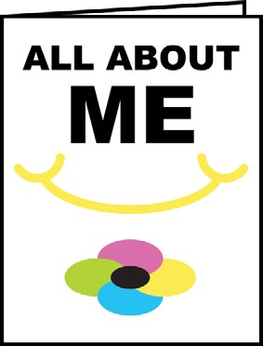
Use the OSP to Support the Development of the “All About Me” Portfolio, Kindergarten to Grade 6

Here is a chart which outlines how these OSP resources relate to each
of the education and career/life planning inquiry questions.

 | Kindergarten to Grade 3 | Grades 4 to 6
Who am I? | Complete My Essential Skills – Primary  Complete My Work Habits – Primary  Use a Pan Am/Parapan Am problem-based learning activity focused on the skills you want to develop | Complete My Essential Skills – Junior  Complete My Work Habits – Junior  View Discover Your Skills Video  on SkillsZone.ca  Use a Pan Am/Parapan Am problem-based learning activity focused on the skills you want to develop
What are my opportunities? |  | Post Using Essential Skills and Work Habits in Volunteer Jobs at School – Use these sample “job postings” to help show students how they can demonstrate and track their Learning Skills and Work Habits, OSP Work Habits and Essential Skills in different school jobs such as “Kindergarten Helper” and “Bus Patrol”.
Who do I want to become? | Use Connecting Essential Skills and  Work Habits to Guest Speakers | Use Connecting Essential Skills and  Work Habits to Guest Speakers  Research a Career – See how workers use  Essential Skills on the Job. Complete Essential Skills in Jobs and Career Reflection Worksheet.
What is my plan for achieving  my goals? |  | Use the Learning Skills and Work Habits - Setting Goals to Keep Improving  Complete the Ontario Skills Passport Reflection Worksheet after finishing a Volunteer Job at School.

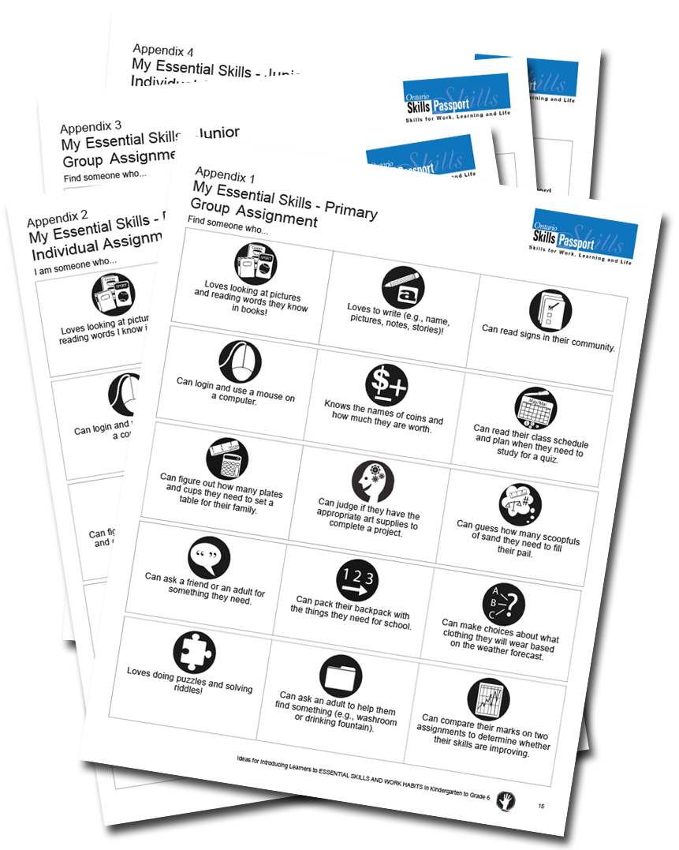
Use the “My Essential Skills” activity (Primary or Junior – Appendix
1, 2, 3 or 4). Once learners have filled in their cards, a whole class discussion follows. The teacher facilitates a discussion on each Essential Skill, going through the card.
Example scripts for teachers:

• What type of meal did you make when you had to measure
ingredients?

• Where would you look to find information about your favourite
sports team?

• Have you ever been at the grocery store and looked at the
Nutritional Information on food (show example)?

• Do you think workers use these same skills on-the-job?

This information can help learners develop their “All About Me” portfolio as they answer the following education and career/life planning inquiry question:
Who am I?

Learners will work in pairs to match the Essential Skill to its definition (Appendix 5). Teachers can use this sheet in a variety of ways. For example, teachers could cut out the Essential Skills titles or icons and ask students to match each skill to the correct definition. A follow-up activity could be to group all of the Numeracy skills together or all of the Thinking skills together. After doing the matching in pairs, learners will do a “Gallery Walk” around the classroom to take note of other group’s work. Learners
should ask other pairs questions about the decisions they made (e.g., “Why did you match that skill with that definition?”). If necessary, pairs will go back to their desk and have an opportunity to revise their definitions. At the end of the lesson, the teacher will display learner work to ensure all definitions have been matched accurately (See Appendix 7).
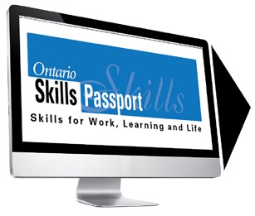
Teachers may want to collect artifacts to display with each Essential Skill. For example, grocery lists can be matched to Document Use. Working in groups or individually, learners can draw a picture or cut and paste an image from a magazine that represents each of the 15 Essential Skills (Appendix 6).

To see how people use their Essential Skills in everyday life, go to the Ontario Skills
Passport website and click on Search for Tasks in Work, Learning and Life.

Teachers will help learners to make connections to the Essential Skills and their own lives.

The teacher will begin by reviewing the definitions of the Essential Skills. Then, the teacher will explain that these Essential Skills are important for success in work, learning and life. The teacher will assign one Essential Skill to each group and have each group describe how they use the particular Essential Skill at home, at school and in their community. The teacher will use the “Scheduling or Budgeting and Accounting” Essential Skill to model as an example. The teacher will talk about how they themselves use Scheduling or Budgeting and Accounting at home, at school, and in the community (e.g., class budgets for supplies, field trips, etc.).
After the teacher modelling, learners will then work on their Essential Skill. After completing their work, groups circulate to add their ideas to all others (e.g., rotate clockwise around the room).

Teachers can go to the Ontario Skills Passport website at www.ontario.ca/skillspassport to find sample tasks in work, learning and life.

This information can help learners develop their “All About Me” portfolio as they answer the following education and career/life planning inquiry question: Who am I?

Students will learn to relate Essential Skills to the world of work by identifying the specific Essential Skills needed for a particular job.
Teachers will model how to complete the “Essential Skills in Jobs” (Appendix 23) sheet. The teacher will begin by displaying the form with “Custodian” as the job. Ask learners to identify (using a checkmark) which skills a custodian uses to complete the requirements of their job. Discuss the specific Essential Skills, and give examples, the custodian performs in his/her job.

Go to the OSP website to see sample tasks that custodians do on-the-job.
Click on Search for Tasks By Occupation and NOC 6661 – Light Duty Cleaners.

Inquiry questions include:

• Do you think the same skills are used in different occupations?

• Do you use these skills in school and at home?

This information can help learners develop their “All About Me” portfolio as they answer the following education and career/life planning inquiry questions: Who am I? What are my opportunities?

To help introduce the notion of “transferable skills”, write the names of the Essential Skills on cards. Put the
cards in a backpack. Ask learners to guess what Essential Skills are used in nearly all occupations and in daily life. Putting the cards in a backpack helps illustrate the concept of transferable skills you take with you wherever you go.

Use the “My Work Habits” activity (Primary or Junior – Appendix 9, 10, 11 or 12). Once learners have filled in their cards, a whole class discussion follows. The teacher facilitates a discussion on each work habit, going through the activity card.

Learners will work in pairs to match the Work Habits to its definition (using the information in Appendix
8) by manipulating cut out pieces of paper. After doing the matching in pairs, learners will do a “Gallery Walk” around the classroom to take note of other group’s work. Learners should ask other pairs questions about the decisions they made (e.g., “Why did you match that work habit with that definition?”). If necessary, pairs will go back to their desk and have an opportunity to revise their definitions. At
the end of the lesson, the teacher will display learner work to ensure all definitions have been matched accurately. Working in groups or individually, learners can subsequently draw a picture or cut and paste an image from a magazine that represents each of the 9 work habits. (Appendix 13).
Discuss the Learning Skills and Work Habits on the report card and explain that other words can be used to describe the same work habit. The words we use in a school environment may be a little different from words used in the workplace or in other activities but they have similar meanings.

For example, a coach or volunteer supervisor may have said you are “Reliable” and have good “Teamwork” skills. This is like saying you are “Responsible” and a good “Collaborator”. Knowing different words used to describe work habits can help you relate your school experiences to your experiences outside the classroom.

Teachers can click here to see the links between the OSP work habits and the Learning Skills and Work
Habits from Growing Success. Example scripts for teachers:
• The OSP Work Habits are words employers use to describe the work habits needed for success. Let’s compare them to the Learning Skills and Work Habits in the report card. For example, what is another word for teamwork? (Answer: Collaboration)
• How about if someone says you are reliable? What learning skills and work habits is “reliability” similar to in your report card? (Answer: Responsibility)

This information can help learners develop their “All About Me” portfolio as they answer the following education and career/life planning inquiry questions: Who am I? What are my opportunities? Who do I want to become?

Learners can go to the Ontario Skills Passport (OSP) website to see how people use their work habits in work, learning and life. Go to the OSP website and click on Search for Tasks in Work, Learning and Life.

Learners can use some of the sample tasks on the OSP website to help them set goals and get ideas for improving their own work habits. Learners can record their goal on the Learning Skills and Work Habits - Setting Goals to Keep Improving chart (Appendix 14).

This information can help learners develop their “All About Me” portfolio as they answer the following education and career/life planning inquiry question: What is my plan for achieving my goals?

Pairs of learners will be given a list of Essential Skills and work habits and a school helper/job posting title, such as Lunchroom Helper. Choose school helper jobs that learners would have the opportunity to do in your school or adapt the samples shown below.
Ask learners to brainstorm how Essential Skills and work habits will be demonstrated in these occupations. Learners can compare their lists to the school helper/job postings. Some samples are shown below.
Appendix 15 – Bus Patrol Helper Appendix 16 – Kindergarten Helper Appendix 17 – Lunch Helper Appendix 18 – Morning Announcer Appendix 19 – Office Helper Appendix 20 – Standing Patrol

This information can help learners develop their “All About Me” portfolio as they answer the following education and career/life planning inquiry questions: Who am I? What are my opportunities? Who do I want to become?

Junior learners should be encouraged to take on Volunteer Jobs throughout the school in order to develop their Essential
Skills and work habits. Once they have completed a Volunteer Job, learners should be encouraged to complete the OSP Reflection Worksheet (Appendix 21) and save it in their “All About Me” portfolio.

Learners will continue to learn to relate Essential Skills to the world of work by identifying the specific
Essential Skills needed for a particular job.

Review the previous lesson relating Essential Skills to different jobs (e.g., custodian; volunteer jobs at school). Individually, learners will use the same “Essential Skills in Jobs” form (Appendix 23B) and complete it for a Firefighter. After learners complete the form, the teacher will guide the learners through the OSP Occupational Profile for a Firefighter (NOC 6262) on the Ontario Skills Passport website to review student’s ideas and fill in any missing gaps. At the end of the lesson, if time permits, the teacher and learners will look through the profile to identify the job description, the Essential Skills and levels associated with the job.

This information can help learners develop their “All About Me” portfolio as they answer the following education and career/life planning inquiry question: What are my opportunities?

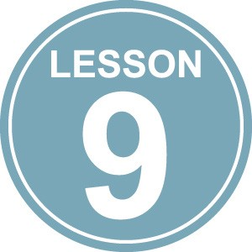
Connecting Essential Skills and Work Habits to a Guest Speaker

While listening to a guest speaker talk about his/her occupation, learners can check off the Essential
Skills and work habits that the individual demonstrates on-the-job. See Appendix 22.

This information can help learners develop their “All About Me” portfolio as they answer the following education and career/life planning inquiry question: What are my opportunities?

Learners will conduct research using job postings (e.g., Workopolis.com) and Occupational Profiles from the Ontario Skills Passport Website.
A National Occupation Classification (NOC) Code has been assigned by the government to each occupation in Canada. Click here to learn more about NOC Codes. Learners will use the internet to research different job postings related to a career (e.g., engineer, journalist, truck driver) using NOC Codes contained in the Ontario Skills Passport Occupational Profiles.
After reading the job postings listing the job description and necessary abilities and skills, and reviewing the appropriate OSP Occupational Profile, learners will use the “Essential Skills in Jobs” form (Appendix
23B) and complete it for the career they have researched. When they have completed this assignment, learners should complete the Career Reflection Worksheet (Appendix 24) and save it in their “All About Me” portfolio.

This information can help learners develop their “All About Me” portfolio as they answer the following education and career/life planning inquiry question: What are my opportunities?

Conclusion

In 2013, The Ontario Ministry of Education released the “Creating Pathways to Success: An Education and Career/Life Planning Program for Ontario Schools.” This document describes a comprehensive education and career/life planning program for Kindergarten to Grade 12 designed to help students achieve their personal goals and become competent, successful, and contributing members of society. Effective September 2014, teachers of students in Kindergarten to Grade 6 are required to create “All About Me” portfolios for each child.

This portfolio will:

“ provide a structure for, and serve as a record of, this learning process. Students capture evidence related to the four areas of learning for their portfolio or IPP in all their subjects or courses at school and in various endeavours and activities at home and in the community. A process must be in place at
every school to support students in documenting their learning in education and career/life planning in a portfolio or IPP. This process must include the opportunity for students to review and share evidence of their learning with their teacher(s) and, where possible, their parents at least twice a year.”
In this Elementary Resource, numerous opportunities have been provided for K-6 learners to develop and demonstrate their Essential Skills and work habits and reflect on how they can further develop these skills to meet their goals. To meet the requirements of the “All About Me” portfolio, included in Appendix 25 is an Essential Skills and Work Habits Progress Sheet. Learners should be encouraged to complete this reflection each term and save it in their portfolio to provide learners, parents and teachers the opportunity of seeing progress in skills development over time.

This information can help learners develop their “All About Me” portfolio as they answer the following education and career/life planning inquiry question: Who am I? What is my plan for achieving my goals?

Appendix 1
My Essential Skills - Primary
Group Assignment
Find someone who...

Loves looking at pictures and reading words they know in books! | Loves to write (e.g., name, pictures, notes, stories)! | Can read signs in their community.

Can login and use a mouse on a computer. | Knows the names of coins and  how much they are worth. | Can read their class schedule and plan when they need to study for a quiz.

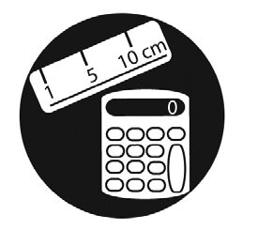  Can figure out how many plates and cups they need to set a table for their family. | Can judge if they have the appropriate art supplies to complete a project. | 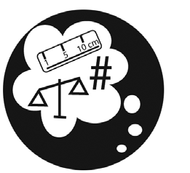  Can guess how many scoopfuls of sand they need to fill their pail.

Can ask a friend or an adult for something they need. | Can pack their backpack with the things they need for school. | Can make choices about what clothing they will wear based on the weather forecast.

Loves doing puzzles and solving riddles! | Can ask an adult to help them find something (e.g., washroom or drinking fountain). | Can compare their marks on two assignments to determine whether their skills are improving.

My Essential Skills - Primary
Group Assignment - Answer Key
Find someone who...

Loves looking at pictures and reading words they know in books! | Loves to write (e.g., name, pictures, notes, stories)! | Can read signs in their community.
READING TEXT | WRITING | DOCUMENT USE

Can login and use a mouse on a computer. | Knows the names of coins and  how much they are worth. | Can read their class schedule and plan when they need to study for a quiz.
COMPUTER USE | MONEY MATH | SCHEDULING OR BUDGETING AND ACCOUNTING

Can figure out how many plates and cups they need to set a table for their family. | Can judge if they have the appropriate art supplies to complete a project. | Can guess how many scoopfuls of sand they need to fill their pail.
MEASUREMENT AND CALCULATION | CRITICAL THINKING | NUMERICAL ESTIMATION

Can ask a friend or an adult for something they need. | Can pack their backpack with the things they need for school. | Can make choices about what clothing they will wear based on the weather forecast.
ORAL COMMUNICATION | JOB TASK PLANNING AND ORGANIZING | DECISION MAKING

Loves doing puzzles and solving riddles! | Can ask an adult to help them find something (e.g., washroom or drinking fountain). | Can compare their marks on two assignments to determine whether their skills are improving.
PROBLEM SOLVING | FINDING INFORMATION | DATA ANALYSIS

Appendix 2
My Essential Skills - Primary
Individual Assignment
I am someone who...

Loves looking at pictures and reading words I know in books! | Loves to write (e.g., name, pictures, notes, stories)! | Can read signs in my community.

Can login and use a mouse on a computer. | Knows the names of coins and  how much they are worth. | Can read my class schedule and plan when I need to study for a quiz.

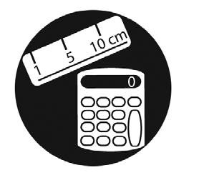  Can figure out how many plates and cups I need to set a table for my family. | Can judge if I have the appropriate art supplies to complete a project. | 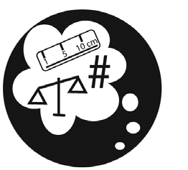  Can guess how many scoopfuls of sand I need to fill my pail.

Can ask a friend or an adult for something I need. | Can pack my backpack with the  things I need for school. | Can make choices about what clothing I will wear based on the weather forecast.

Loves doing puzzles and solving riddles! | Can ask an adult to help me find something (e.g., washroom or drinking fountain). | Can compare my marks on two assignments to determine whether my skills are improving.
My Essential Skills - Primary
Individual Assignment - Answer Key
I am someone who...

Loves looking at pictures and reading words I know in books! | Loves to write (e.g., name, pictures, notes, stories)! | Can read signs in my community.
READING TEXT | WRITING | DOCUMENT USE

Can login and use a mouse on a computer. | Knows the names of coins and  how much they are worth. | Can read my class schedule and plan when I need to study for a quiz.
COMPUTER USE | MONEY MATH | SCHEDULING OR BUDGETING AND ACCOUNTING

Can figure out how many plates and cups I need to set a table for my family. | Can judge if I have the appropriate art supplies to complete a project. | Can guess how many scoopfuls of sand I need to fill my pail.
MEASUREMENT AND CALCULATION | CRITICAL THINKING | NUMERICAL ESTIMATION

Can ask a friend or an adult for something I need. | Can pack my backpack with the  things I need for school. | Can make choices about what clothing I will wear based on the weather forecast.
ORAL COMMUNICATION | JOB TASK PLANNING AND ORGANIZING | DECISION MAKING

Loves doing puzzles and solving riddles! | Can ask an adult to help me find something (e.g., washroom or drinking fountain). | Can compare my marks on two assignments to determine whether my skills are improving.
PROBLEM SOLVING | FINDING INFORMATION | DATA ANALYSIS
Appendix 3
My Essential Skills - Junior
Group Assignment
Find someone who...

Loves reading magazines, comics,  chapter books... anything! | Loves to write stories or  keep a diary. | Can use an agenda to record due dates for assignments.

Loves to use computers and explore new technology at home and in class. | Can add coins and bills. | Can schedule time to complete homework and other activities like hockey practice or music lessons.

Loves to help measure ingredients to make a simple meal. | Can judge the suitability and reliability of using different websites for a project. | Can estimate the time it will take to read a book or complete an assignment.

Loves to talk and listen to their friends. They like to answer questions and present their ideas to others. | Likes to help organize events like school bake sales or parties. | Can select the materials or equipment needed to complete a craft project or play a sport.

Can ask others to join their team when they don’t have enough people to play the game. | Loves to find out information about their favourite topic  (e.g., sports, movies, bands). | Can compare two foods to determine which one is the healthier choice.
My Essential Skills - Junior
Group Assignment - Answer Key
Find someone who...

Loves reading magazines, comics,  chapter books... anything! | Loves to write stories or  keep a diary. | Can use an agenda to record due dates for assignments.
READING TEXT | WRITING | DOCUMENT USE

Loves to use computers and explore new technology at home and in class. | Can add coins and bills. | Can schedule time to complete homework and other activities like hockey practice or music lessons.
COMPUTER USE | MONEY MATH | SCHEDULING OR BUDGETING AND ACCOUNTING

Loves to help measure ingredients to make a simple meal. | Can judge the suitability and reliability of using different websites for a project. | Can estimate the time it will take to read a book or complete an assignment.
MEASUREMENT AND CALCULATION | CRITICAL THINKING | NUMERICAL ESTIMATION

Loves to talk and listen to their friends. They like to answer questions and present their ideas to others. | Likes to help organize events like school bake sales or parties. | Can select the materials or equipment needed to complete a craft project or play a sport.
ORAL COMMUNICATION | JOB TASK PLANNING AND ORGANIZING | DECISION MAKING

Can ask others to join their team when they don’t have enough people to play the game. | Loves to find out information about their favourite topic  (e.g., sports, movies, bands). | Can compare two foods to determine which one is the healthier choice.
PROBLEM SOLVING | FINDING INFORMATION | DATA ANALYSIS
Appendix 4
My Essential Skills - Junior
Individual Assignment
I am someone who...

Loves reading magazines, comics,  chapter books... anything! | Loves to write stories or  keep a diary. | Can use an agenda to record due dates for assignments.

Loves to use computers and explore new technology at home and in class. | Can add coins and bills. | Can schedule time to complete homework and other activities like hockey practice or music lessons.

Loves to help measure ingredients to make a simple meal. | Can judge the suitability and reliability of using different websites for a project. | Can estimate the time it will take to read a book or complete an assignment.

Loves to talk and listen to my friends. I like to answer questions and present my ideas to others. | Likes to help organize events like school bake sales or parties. | Can select the materials or equipment needed to complete a craft project or play a sport.

Can ask others to join our team when we don’t have enough people to play the game. | Loves to find out information about my favourite topic  (e.g., sports, movies, bands). | Can compare two foods to determine which one is the healthier choice.

My Essential Skills - Junior
Individual Assignment - Answer Key
I am someone who...

Loves reading magazines, comics,  chapter books... anything! | Loves to write stories or  keep a diary. | Can use an agenda to record due dates for assignments.
READING TEXT | WRITING | DOCUMENT USE

Loves to use computers and explore new technology at home and in class. | Can add coins and bills. | Can schedule time to complete homework and other activities like hockey practice or music lessons.
COMPUTER USE | MONEY MATH | SCHEDULING OR BUDGETING AND ACCOUNTING

Loves to help measure ingredients to make a simple meal. | Can judge the suitability and reliability of using different websites for a project. | Can estimate the time it will take to read a book or complete an assignment.
MEASUREMENT AND CALCULATION | CRITICAL THINKING | NUMERICAL ESTIMATION

Loves to talk and listen to my friends. I like to answer questions and present my ideas to others. | Likes to help organize events like school bake sales or parties. | Can select the materials or equipment needed to complete a craft project or play a sport.
ORAL COMMUNICATION | JOB TASK PLANNING AND ORGANIZING | DECISION MAKING

Can ask others to join our team when we don’t have enough people to play the game. | Loves to find out information about my favourite topic  (e.g., sports, movies, bands). | Can compare two foods to determine which one is the healthier choice.
PROBLEM SOLVING | FINDING INFORMATION | DATA ANALYSIS

OSP Icon and Essential Skill Definition

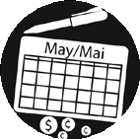
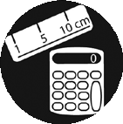
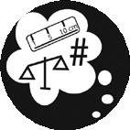

Reading Text Writing Document Use Computer Use
Oral Communication

Money Math

Scheduling or Budgeting and Accounting

Measurement and
Calculation

Data Analysis

Numerical Estimation

Job Task Planning and
Organizing

Decision Making Problem Solving Finding Information Critical Thinking
The use of any type of computerized technology.

The measurement and calculation of quantities, areas, volumes, and/or distances.

Planning for the best use of time and money, as well as monitoring the use of time and money.

Making judgments by using criteria to evaluate ideas and information and the related consequences.

The preparation of written materials for a variety of purposes. Completing such tasks as filling in forms,
writing text and using computers to write.

Making a choice among options using appropriate information.

The use of a variety of sources, including written text, people, computerized databases, and information systems

The identification and solving of problems.

Reading materials in the form of sentences or paragraphs such as notes, letters, memos, manuals, specifications, books, reports and journals.

Planning and organizing your own work.

Using verbal skills to exchange ideas and information with
others.

The use of mathematical skills in making financial transactions, such as handling cash, preparing bills, and making payments.
The collection and analysis of data in numerical form. Reading different types of material such as labels, signs,
lists, tables, graphs, forms, diagrams, blueprints and other
similar material.

The measurement and calculation of quantities, areas, volumes, and/or distances.

In the boxes below, draw a picture or cut and paste an image out of a magazine that
represents each of the 15 Essential Skills. We will post these in our classroom.

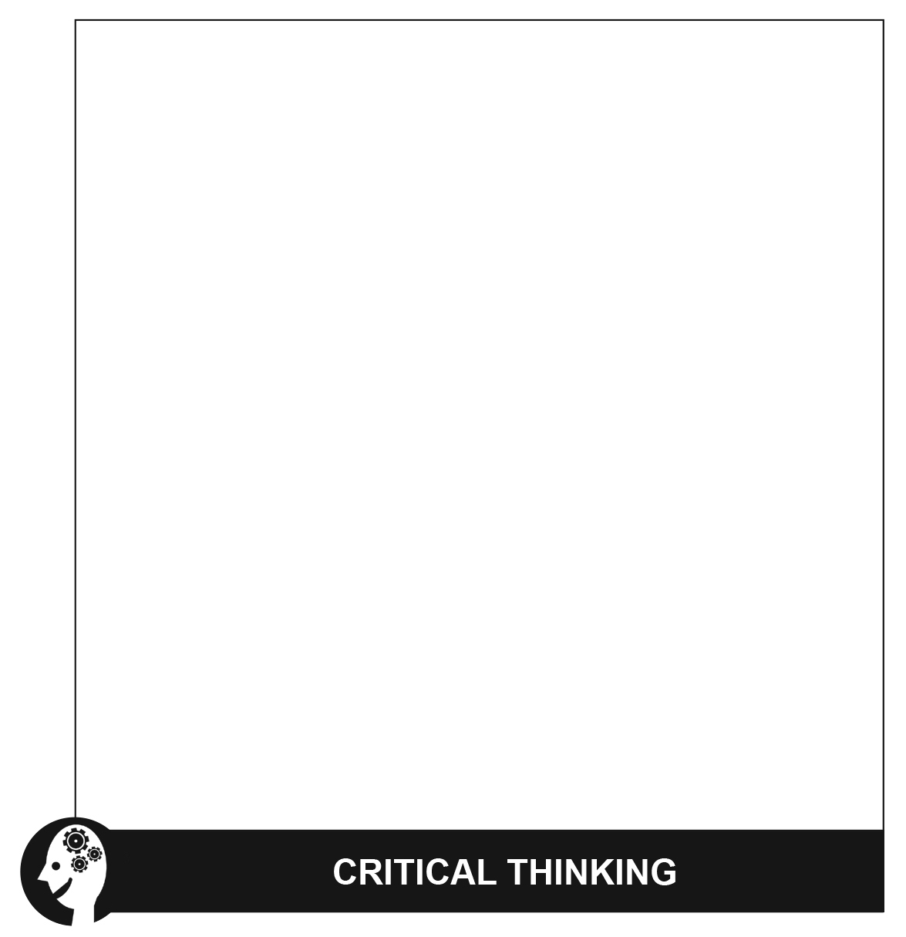

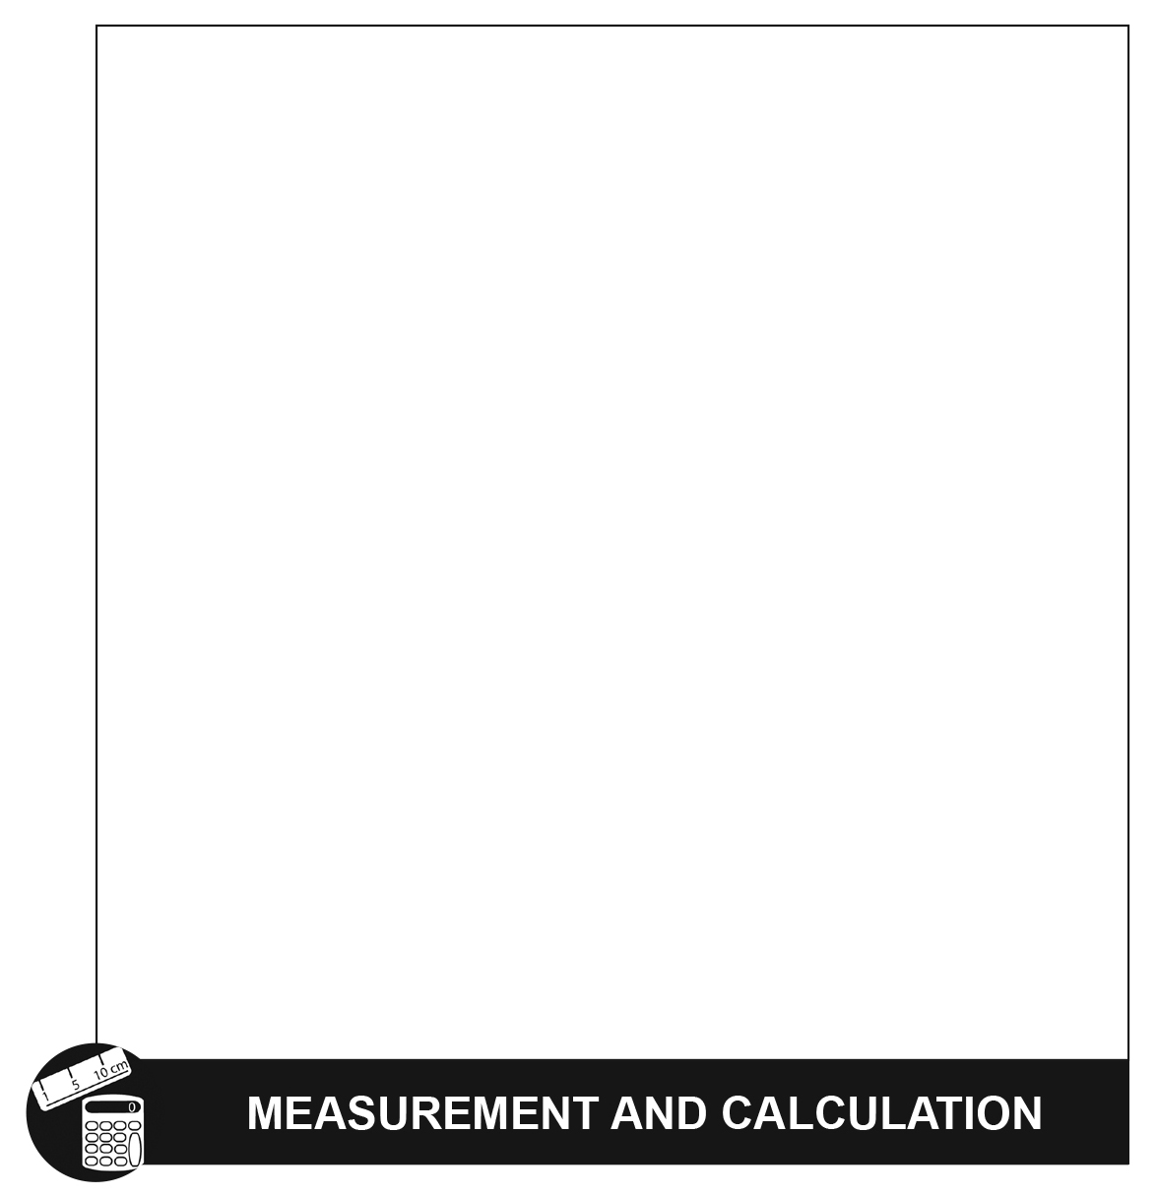

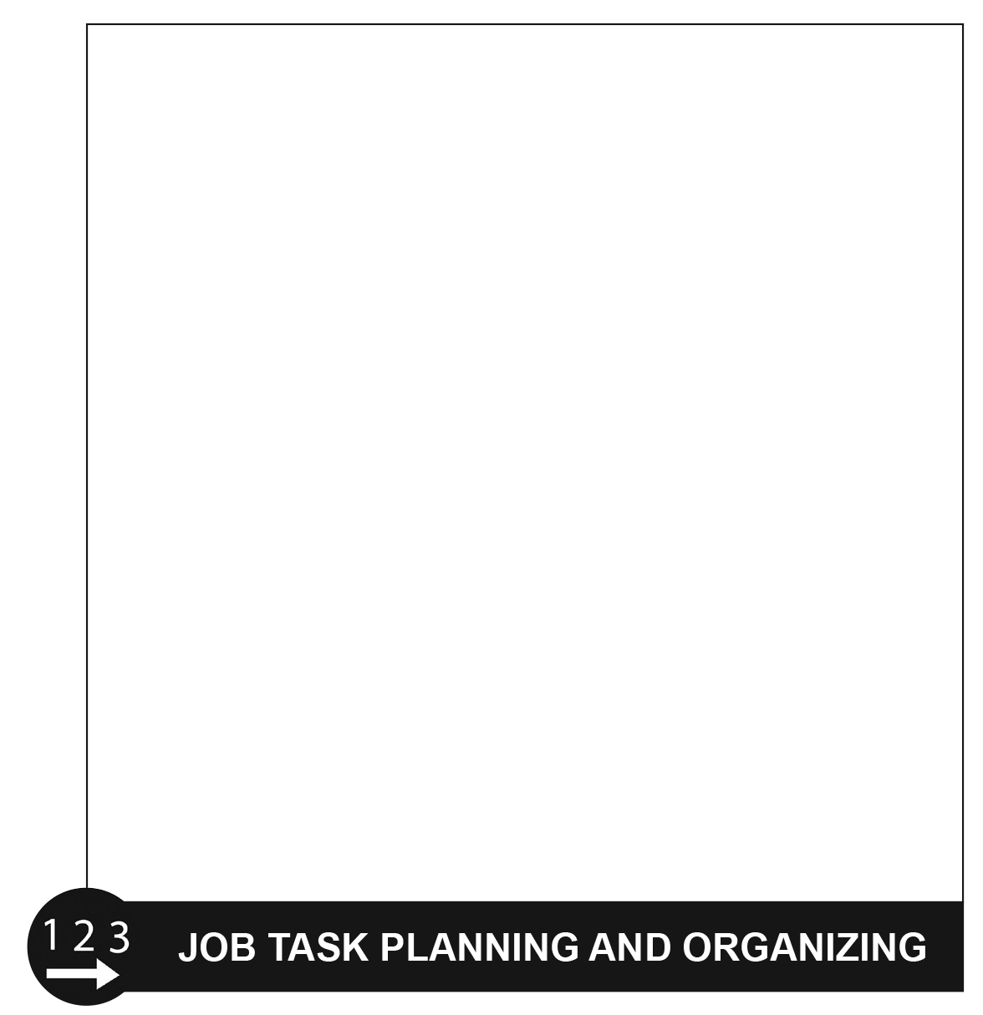

OSP Icon Essential Skill Sample Tasks

 | Reading Text  Reading materials in the form of sentences or paragraphs such as notes, letters, memos, manuals, specifications, books, reports and journals. | • Read captions under a picture.  • Read magazines, comics, chapter books... anything!  • Read a movie review to decide if you want to go and  see it.
 | Writing  The preparation of written materials for  a variety of purposes. Completing such tasks as filling in forms, writing text and using computers to write. | • Write short reminder notes in an agenda or daily planner.  • Write entries in a diary.  • Write a short story.  • Write a book report.
 | Document Use  Reading different types of material such as labels, signs, lists, tables, graphs, forms, diagrams, blueprints and other similar material. | • Read signs in the community.  • Use an agenda to record due dates for assignments.  • Check the sports scores in the newspaper to identify which teams won last night.  • Use maps and graphs in a project.
 | Computer Use  The use of any type of computerized technology. | • Login and use a mouse on a computer.  • Use computers at home and in class.  • Explore new technology at home or in class.  • Send and receive e-mail messages.
 | Oral Communication  Using verbal skills to exchange ideas and information with others. | • Ask a friend or adult for something I need.  • Answer questions in class and give presentations.  • Order food in a restaurant.

Numeracy

OSP Icon Essential Skill Sample Tasks

 | Money Math  The use of mathematical skills in making financial transactions, such as handling cash, preparing bills, and making payments. | • Know the names of coins and their monetary value.  • Add coins and bills.  • Calculate how much money the class raised in a  fundraiser.
 | Scheduling or Budgeting and  Accounting  Planning for the best use of time and money, as well as monitoring the use of time and money. | • Read the class schedule and plan time to study for a quiz.  • Schedule time to complete homework and other activities like hockey practice or music lessons after school.  • Look for the best deal when buying something to keep on budget.
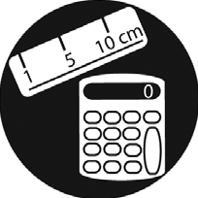 | Measurement and Calculation  The measurement and calculation  of quantities, areas, volumes, and/or  distances. | • Determine how many plates and cups are needed to set a table for the family.  • Help measure ingredients to make a simple meal.  • Weigh yourself to make sure you are within a healthy range for your height.  • Figure out how many cupcakes are needed for a sports team fundraiser.
 | Data Analysis  The collection and analysis of data in numerical form. | • Compare marks on two assignments to determine whether skills are improving.  • Compare two foods to determine which one is the  healthier choice.  • Calculate course grades by averaging marks received on assignments.  • Predict which sports team will win using game statistics over a period of time.
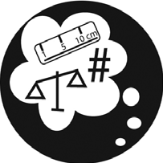 | Numerical Estimation  The production of estimates in numerical terms. | • Guess how many scoopfuls of sand are needed to fill a pail.  • Estimate the time it will take to read a book or complete an assignment.  • Track the wins and losses of a favourite sports team.

Thinking Skills

OSP Icon Essential Skill Sample Tasks

 | Job Task Planning and  Organizing  Planning and organizing your own work. | • Pack your backpack with the things needed for  school.  • Help organize events like school bake sales or parties.
 | Decision Making  Making a choice among options using appropriate information. | • Make choices about what clothing to wear based  on the weather forecast.  • Select the materials or equipment needed to complete a craft project or play a sport.  • Select the assignment to work on first using due dates and the relative difficulty of each assignment.  • Look at all options before making a decision.
 | Problem Solving  The identification and solving of problems. | • Complete puzzles.  • Solve riddles.  • Ask others to join the team when there is not enough people to play the game.
 | Finding Information  The use of a variety of sources, including written text, people, computerized databases, and information systems. | • Find the washroom or drinking fountain by asking an adult for help.  • Find information about a favourite music star.  • Find out when the project is due by asking the  teacher or another student.
 | Critical Thinking  Making judgments by using criteria to evaluate ideas and information and the related consequences. | • Judge the suitability of art supplies to complete a project.  • Judge the suitability and reliability of using different websites for a project.  • Use rubrics provided by the teacher to decide if an assignment is ready to hand in.

Appendix 8

Work Habits Reference Sheet

OSP Icon Work Habits Descriptors

Working Safely
• Working in a manner that prevents injury to self and others
• Reporting unsafe conditions
• Participating in health and safety training, as required
• Using and wearing all required protective equipment and devices
Teamwork
• Work willingly with others
• Showing respect for the ideas and opinions of others
• Taking responsibility for his or her share of the work
• Contributing to the team effort by sharing information, resources, and expertise
Reliability
• Being punctual • Following directions
• Giving attention to detail • Using time effectively and producing work on time
• Acting in accordance with health and safety practices
Organization
• Organizing work priorities when faced with a number of tasks
• Devising and following a coherent plan to complete a task
• Revising the plan when necessary to complete a task or to make improvements
Working Independently
• Accomplishing tasks independently
• Independently selecting, evaluating, and using appropriate materials, tools, resources, and activities
• Using prior knowledge and experience to solve problems and make decisions
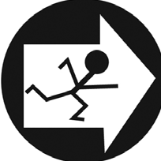 | Initiative  • Beginning and completing tasks with little prompting  • Approaching new tasks with confidence and a positive attitude  • Seeking assistance when necessary
Self-advocacy
• Asking questions and seeking clarification, where appropriate
• Identifying and making use of appropriate resources and support when needed
• Being proactive regarding individual rights and responsibilities, where appropriate
Customer Service
• Listening effectively to determine and meet clients’ needs
• Interacting positively with both co-workers and clients/customers
• Endeavouring to meet and exceed expectations
• Creating a positive impression of the company or organization
Entrepreneurship
• Recognizing and acting on opportunities • Showing perseverance
• Being innovative and creative • Being versatile and resourceful

My Work Habits – Primary
– Individual Assignment

I am someone who…

Can tell an adult when something is not safe (e.g., glass on the ground, water on the floor).
Cheers for my teammates and shows good sportsmanship.
Comes to school every day and on time.

Puts books, pencils and art materials back in the right spot.
Can complete puzzles, crafts and games on my own.
Loves to help my friends when they need it.

Asks for help when I need it. Can greet a new student or
class visitor with a smile.
Can run a lemonade stand to make money for a charity.

My Work Habits – Primary
– Individual Assignment – Answer Key

I am someone who…

Can tell an adult when something is not safe (e.g., glass on the ground, water on the floor). | Cheers for my teammates and shows good sportsmanship. | Comes to school every day and on time.
WORKING SAFELY | TEAMWORK | RELIABILITY

Puts books, pencils and art materials back in the right spot. | Can complete puzzles, crafts and games on my own. | Loves to help my friends when they need it.
ORGANIZATION | WORKING INDEPENDENTLY | INITIATIVE

Asks for help when I need it. | Can greet a new student or  class visitor with a smile. | Can run a lemonade stand to make money for a charity.
SELF-ADVOCACY | CUSTOMER SERVICE | ENTREPRENEURSHIP

My Work Habits – Primary
– Group Assignment

Find someone who…

Can tell an adult when something is not safe (e.g., glass on the ground, water on the floor).
Cheers for their teammates and shows good sportsmanship.
Comes to school every day and on time.

Puts books, pencils and art materials back in the right spot.
Can complete puzzles, crafts and games on their own.
Loves to help their friends
when they need it.

Asks for help when they need it. Can greet a new student or
class visitor with a smile.
Can run a lemonade stand to make money for a charity.

My Work Habits – Primary
– Group Assignment – Answer Key

Find someone who…

Can tell an adult when something is not safe (e.g., glass on the ground, water on the floor). | Cheers for their teammates and  shows good sportsmanship. | Comes to school every day and on time.
WORKING SAFELY | TEAMWORK | RELIABILITY

Puts books, pencils and art materials back in the right spot. | Can complete puzzles, crafts and games on their own. | Loves to help their friends  when they need it.
ORGANIZATION | WORKING INDEPENDENTLY | INITIATIVE

Asks for help when they need it. | Can greet a new student or  class visitor with a smile. | Can run a lemonade stand to make money for a charity.
SELF-ADVOCACY | CUSTOMER SERVICE | ENTREPRENEURSHIP

My Work Habits – Junior
– Individual Assignment

I am someone who…

Wears a helmet when I bike,
rollerblade or snowboard.
Completes my fair share of group assignments.
Returns items I borrow on time
(e.g., library books).

Uses my planner to know when assignments are due.
Can be depended on to complete homework and assignments.
Volunteers in the school and participates in extracurricular activities.

Can stand up to bullies. Is friendly with people, even if I’m having a bad day.
Thinks of ideas for fundraisers for
school trips or social justice events.

My Work Habits – Junior
– Individual Assignment – Answer Key

I am someone who…

Wears a helmet when I bike,  rollerblade or snowboard. | Completes my fair share of group assignments. | Returns items I borrow on time  (e.g., library books).
WORKING SAFELY | TEAMWORK | RELIABILITY

Uses my planner to know when assignments are due. | Can be depended on to complete homework and assignments. | Volunteers in the school and participates in extracurricular activities.
ORGANIZATION | WORKING INDEPENDENTLY | INITIATIVE

Can stand up to bullies. | Is friendly with people, even if I’m having a bad day. | Thinks of ideas for fundraisers for  school trips or social justice events.
SELF-ADVOCACY | CUSTOMER SERVICE | ENTREPRENEURSHIP

My Work Habits – Junior
– Group Assignment

Find someone who…

Wears a helmet when they bike, rollerblade or snowboard.
Completes their fair share of
group assignments.
Returns items they borrow on time (e.g., library books).

Uses their planner to know
when assignments are due.
Can be depended on to complete homework and assignments.
Volunteers in the school and participates in extracurricular activities.

Can stand up to bullies. Is friendly with people, even if they’re having a bad day.
Thinks of ideas for fundraisers for
school trips or social justice events.

My Work Habits – Junior
– Group Assignment – Answer Key

Find someone who…

Wears a helmet when they bike, rollerblade or snowboard. | Completes their fair share of  group assignments. | Returns items they borrow on time (e.g., library books).
WORKING SAFELY | TEAMWORK | RELIABILITY

Uses their planner to know  when assignments are due. | Can be depended on to complete homework and assignments. | Volunteers in the school and participates in extracurricular activities.
ORGANIZATION | WORKING INDEPENDENTLY | INITIATIVE

Can stand up to bullies. | Is friendly with people, even if they’re having a bad day. | Thinks of ideas for fundraisers for  school trips or social justice events.
SELF-ADVOCACY | CUSTOMER SERVICE | ENTREPRENEURSHIP

In the boxes below, draw a picture or cut and paste an image out of a magazine that represents each of the 9
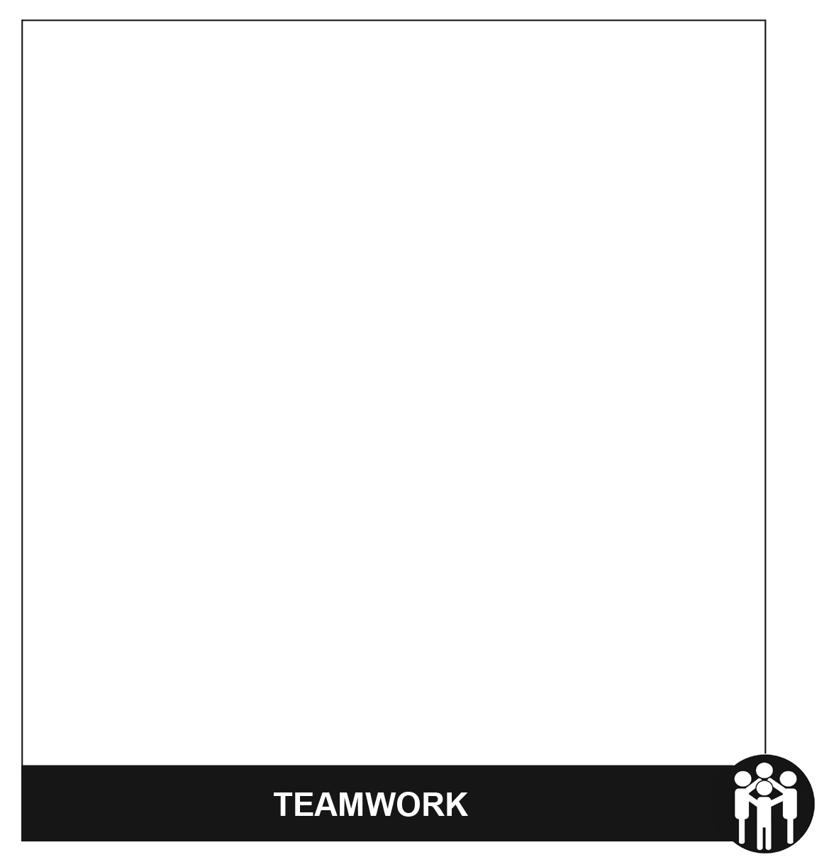
Work Habits. We will post these in our classroom.

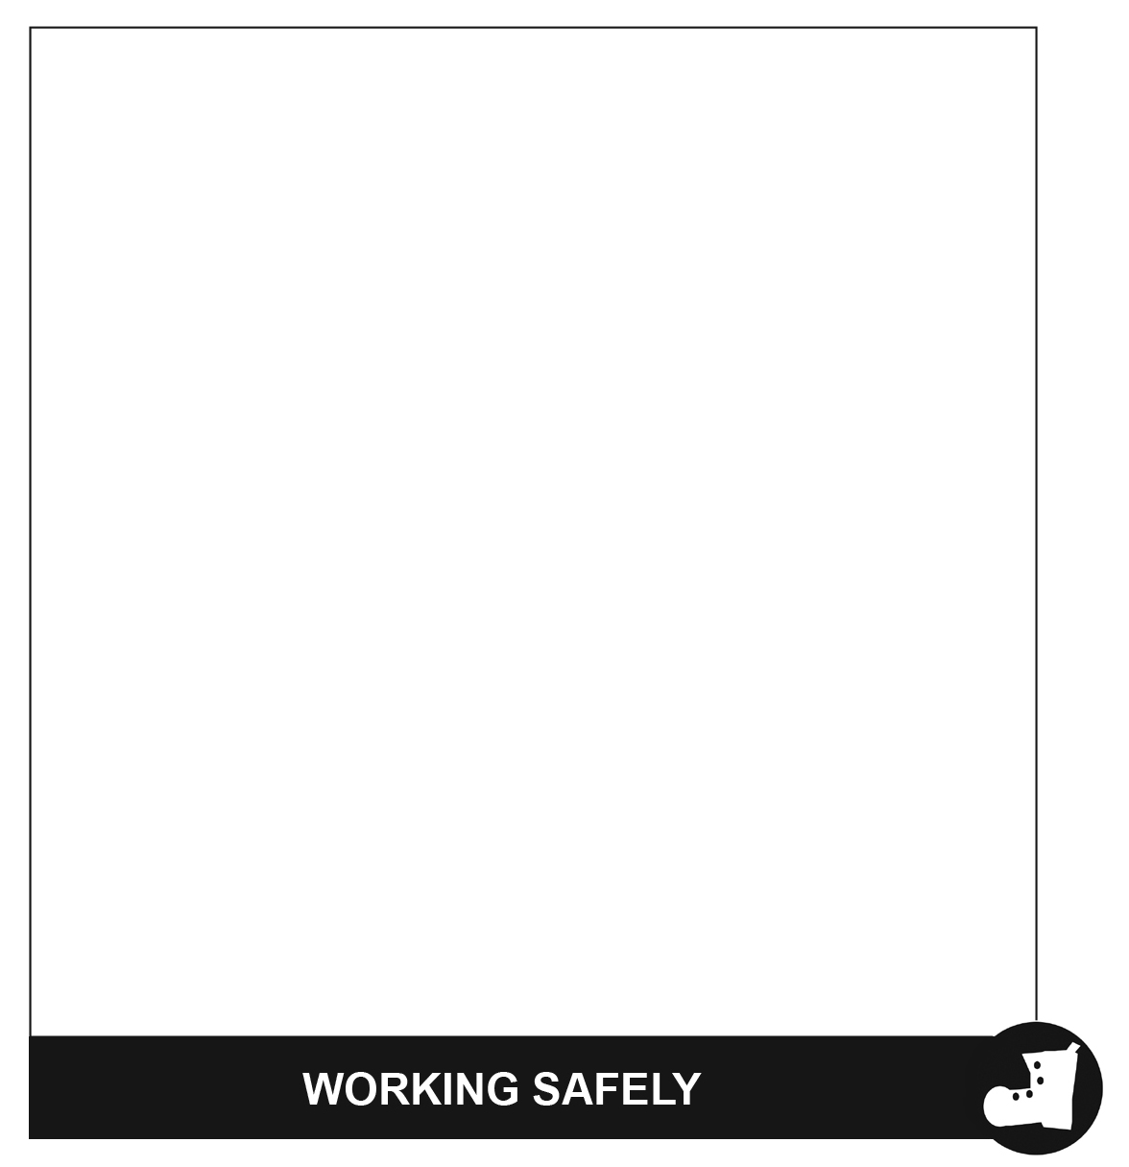

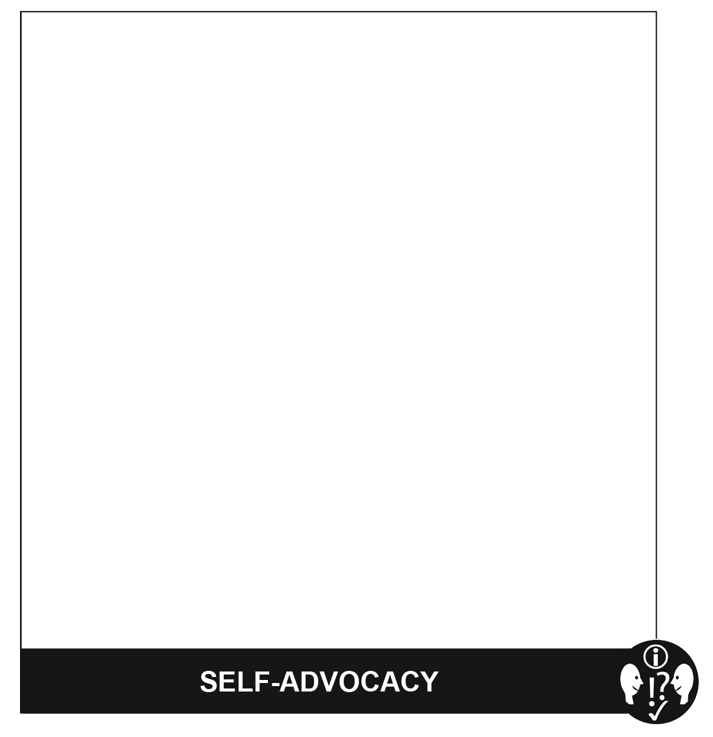

Setting Goals to Keep Improving
We know that developing Learning Skills and Work Habits are very important in determining student success at
school and in life.

• How well-developed are your Learning Skills and Work Habits?

• How can you continue to develop your Learning Skills and Work Habits?

One way to continue to develop skills and habits is to set goals and work on strategies to achieve them. What goals would you like to set to improve?

Learning Skills & Work Habits | My Personal Goal For Improvement
Responsibility  (Reliability, Working Safely) | To improve responsibility I will…
Organization | To improve my organization I will…
Independent Work  (Working Independently) | To improve my ability to work independently I will…
Collaboration  (Teamwork) | To improve my ability to collaborate and work with others I will…
Initiative  (Entrepreneurship) | To show greater initiative I will…
Self-Regulation  (Working Independently, Initiative) | To develop greater self-regulation I will…

Get sample tasks to show how people use their work habits in everyday life.
Go to the Ontario Skills Passport website at www.ontario.ca/skillspassport and click on
Search for tasks in work, learning and life.

We are seeking students in Grade 4-6 to take on the role of Bus Patrol Helper.

The requirements for this position are listed below. The Learning Skills and Work Habits you will have the opportunity to build and demonstrate are shown in brackets followed by other words in italics that can be used to describe the same work habit.

For example, a coach or volunteer supervisor may have said you are “Reliable” and have good “Teamwork” skills. This is like saying you are “Responsible” and a good “Collaborator”. Knowing different words used to describe work habits can help you relate your school experiences to your experiences outside the classroom.

As a Bus Patrol Helper, you will also have an opportunity to build and demonstrate your Essential Skills. These
skills are used in work, learning and life. Essential Skills are shown in bold after the work habits.

Overall Responsibilities
• Always wear your safety vest so you can be identified by students and staff. (Responsibility, Organization,
Reliability, Working Safely)

• Be a positive role model for all students at all times. (Self-Regulation, Responsibility, Initiative, Reliability)

• Read all bus safety rules and be prepared to explain them to other students. (Reading Text, Oral
Communication)

• Communicate well with other Bus Patrol Helpers, Bus Driver, Staff Members, and students. (Collaboration,
Teamwork, Oral Communication)

• Assist students, as appropriate, while ensuring your own safety. Always be sure to incorporate your Bus Patrol
Safety Training. (Responsibility, Initiative, Reliability, Customer Service)

• Be a good problem solver. For example, a student will not listen and is not obeying the bus rules. Inform the bus driver or a staff member immediately. (Initiative, Responsibility, Self-Regulation, Reliability, Working Safely, Self- advocacy, Oral Communication, Problem Solving)
• Find a replacement Bus Patrol should you be unable to complete one of your shifts. (Responsibility, Initiative,
Reliability)

When you are on the bus …
• Sit in your assigned seat, ensuring that bus patrol helpers are spread out with representation at the front of the bus, in the middle of the bus and at the back of the bus. (Organization, Responsibility, Reliability)
• Work collaboratively with your fellow Bus Patrol Helpers to communicate any issues. (Collaboration, Teamwork,
Oral Communication)

• In a positive and supportive way, remind students to follow the bus rules and to treat each other with respect.
(Responsibility, Initiative, Reliability, Oral Communication)

• At the end of your bus ride, speak with the Bus Driver and School Staff if there were any concerns. (Responsibility, Initiative, Collaboration, Reliability, Teamwork, Oral Communication)
• Assist students as they descend off of the bus and allocate at least two bus patrol helpers to the Kindergarten students. (Responsibility, Organization, Collaboration, Reliability, Teamwork)

When the bus arrives at school in the morning …
• Ensure that no one gets off of the bus until a supervisor greets the bus. (Responsibility, Reliability)

At the end of the day….
• Arrive promptly, at the end of the day, to the bus line-up. (Responsibility, Reliability)

• Walk all students to their designated area, paying special attention to the Kindergarten students. Ensure that
one Bus Patrol Helper is at the front of the line and another Bus Patrol Helper is at the back of the line to prevent
any stragglers. (Responsibility, Organization, Collaboration, Reliability, Teamwork)

• Assist the teacher on duty, as appropriate, while waiting for the bus to arrive - help students get to the right bus line, remind students to sit quietly and follow the school rules while waiting for the bus. (Responsibility, Collaboration, Reliability, Working Safely, Teamwork, Oral Communication)
• Once the teacher has given the signal, guide students to the bus and assist them to get on the bus and into their seats safely. (Responsibility, Reliability)

You can transfer your Essential Skills and work habits to everyday life or the next place you go – whether it’s further education, training or the workplace. More information on how you use your Essential Skills and work habits in everyday life is on the Ontario Skills Passport website.
Identifying and reflecting on the Essential Skills and work habits you demonstrate as a Bus Patrol Helper will help you develop your “All About Me” portfolio as you answer the four education and career/life planning inquiry questions: Who am I? What are my opportunities? Who do I want to become? What is my plan for achieving my goals?

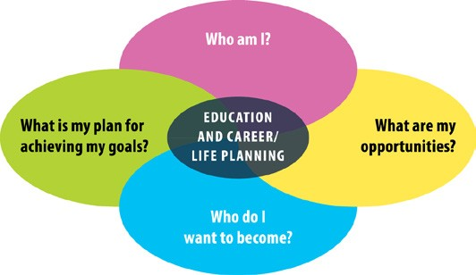

ontario.ca/skillspassport

We are seeking students in Grade 4-6 to take on the role of Kindergarten Helper. As a Kindergarten Helper, you
will assist with Kindergarten students in the classroom and outside in the Kindergarten play area.

The requirements for this position are listed below. The Learning Skills and Work Habits you will have the opportunity to build and demonstrate are shown in brackets followed by other words in italics that can be used to describe the same work habit.

For example, a coach or volunteer supervisor may have said you are “Reliable” and have good “Teamwork” skills. This is like saying you are “Responsible” and a good “Collaborator”. Knowing different words used to describe work habits can help you relate your school experiences to your experiences outside the classroom.

As a Kindergarten Helper, you will also have an opportunity to build and demonstrate your Essential Skills. These
skills are used in work, learning and life. Essential Skills are shown in bold after the work habits.

• Read the classroom rules and be prepared to explain them to students as needed. (Responsibility, Reliability,
Reading Text, Oral Communication)

• Arrive promptly to your assigned classroom or to the kindergarten play area (whichever was predetermined with the classroom teacher) at the very beginning of the nutrition break. (Responsibility, Organization, Reliability, Scheduling or Budgeting and Accounting)
• Actively assist and engage students in outdoor play activities. (Responsibility, Initiative, Reliability, Working
Safely)

• Be a good problem solver. For example, if a student is not listening or following the rules, talk to the student or get the supervising staff member to assist as needed. (Initiative, Responsibility, Reliability, Self-advocacy, Oral Communication, Problem Solving)
• In a positive manner, remind students to follow the rules and treat each other with respect. (Responsibility,
Initiative, Reliability, Customer Service, Oral Communication)

• Work collaboratively with your fellow Kindergarten Helpers and with Staff to discuss plans and issues.
(Collaboration, Teamwork, Oral Communication)

• When the bell rings to go inside, assist staff to “round up all students” and to put all supplies and equipment away. (Responsibility, Initiative, Collaboration, Organization, Reliability, Teamwork)
• When back inside, assist students to remove outdoor clothing and boots and wash their hands for nutrition break. (Responsibility, Collaboration, Reliability, Working Safely)
• Assist in the classroom by helping students to get their lunches from their backpacks and to open containers. (Responsibility, Initiative, Organization, Reliability)
• Remind students to follow the lunch room rules (posted in each classroom). (Responsibility, Initiative, Reliability,
Oral Communication)

• Assist students in cleaning up their lunches. (Initiative, Organization)

• Be a positive role model for all students in the class. (Self-Regulation, Responsibility, Initiative, Reliability)

• Return to your classroom promptly for the next period’s class. (Responsibility, Reliability)

• Talk with teacher to get feedback on interactions and job performance. (Initiative, Self-Regulation, Collaboration,
Reliability, Teamwork, Oral Communication)

• Schedule time to complete your tasks while taking into account your responsibilities in your other classes or extracurricular activities. (Organization, Scheduling or Budgeting and Accounting)
• Find a replacement Kindergarten Helper should you be unable to complete one of your shifts. (Responsibility,
Initiative, Reliability)

You can transfer your Essential Skills and work habits to everyday life or the next place you go – whether it’s
further education, training or the workplace. More information on how you use your Essential Skills and work habits in everyday life is on the Ontario Skills Passport website.
Identifying and reflecting on the Essential Skills and work habits you demonstrate as a Kindergarten Helper will help you develop your “All About Me” portfolio as you answer the four education and career/life planning inquiry questions: Who am I? What are my opportunities? Who do I want to become? What is my plan for achieving my goals?

ontario.ca/skillspassport

We are seeking students in Grade 4-6 to take on the role of Lunch Helper in our Kindergarten to Grade 3
classrooms.

The requirements for this position are listed below. The Learning Skills and Work Habits you will have the opportunity to build and demonstrate are shown in brackets followed by other words in italics that can be used to describe the same work habit.

For example, a coach or volunteer supervisor may have said you are “Reliable” and have good “Teamwork” skills. This is like saying you are “Responsible” and a good “Collaborator”. Knowing different words used to describe work habits can help you relate your school experiences to your experiences outside the classroom.

As a Lunch Helper, you will also have an opportunity to build your Essential Skills. These skills are used in work,
learning and life. Essential Skills are shown in bold after the work habits.

• Arrive on time to your assigned classroom (at the very beginning of the nutrition break). (Responsibility,
Reliability, Scheduling or Budgeting and Accounting)

• Read the rules posted in the classroom. (Responsibility, Reliability, Reading Text)

• Sit in your designated spot except when assisting students. (Responsibility, Reliability)

• Look for ways to assist students in the classroom. For example, help them to open containers when asked.
(Initiative)

• Work collaboratively with the students to remind them of the rules and expectations and to engage in play activities after they have finished their lunch. (Collaboration, Teamwork, Oral Communication)
• Be a good problem solver. For example, a student is not following the rules and is causing problems in the class. Gently remind the student of the rules and get the supervising staff member if the problem continues. (Initiative, Responsibility, Self-advocacy, Oral Communication, Problem Solving)
• Assist students in cleaning up their lunches and in getting ready to go outside. (Organization, Initiative)

• Ensure that all students have left the room, turn out the lights and close the classroom door. (Responsibility,
Reliability)

• Be a role model for all students in the class. (Self-Regulation, Responsibility, Initiative, Reliability)

• Find a replacement Lunch Helper should you be unable to complete one of your shifts. (Responsibility, Reliability)

• Schedule time to complete your tasks while taking into account your responsibilities in your other classes or extracurricular activities. (Organization, Scheduling or Budgeting and Accounting)

You can transfer your Essential Skills and work habits to everyday life or the next place you go – whether it’s further education, training or the workplace. More information on how you use your Essential Skills and work habits in everyday life is on the Ontario Skills Passport website.

Identifying and reflecting on the Essential Skills and work habits you demonstrate as a Lunch Helper will help you develop your “All About Me” portfolio as you answer the four education and career/life planning inquiry questions: Who am I? What are my opportunities? Who do I want to become? What is my plan for achieving my goals?

ontario.ca/skillspassport

We are seeking students in Grade 4-6 to take on the role of Morning Announcer.

The requirements for this position are listed below. The Learning Skills and Work Habits you will have the opportunity to build and demonstrate are shown in brackets after the tasks followed by other words in italics that can be used to describe the same work habit.

For example, a coach or volunteer supervisor may have said you are “Reliable” and have good “Teamwork” skills. This is like saying you are “Responsible” and a good “Collaborator”. Knowing different words used to describe work habits can help you relate your school experiences to your experiences outside the classroom.

As a Morning Announcer, you will also have an opportunity to build and demonstrate your Essential Skills. These
skills are used in work, learning and life. Essential Skills are shown in bold after the work habits.

• Arrive at the office 15 minutes before school starts. (Responsibility, Reliability, Scheduling or Budgeting and
Accounting)

• Double check the schedule to ensure that it is your day and to double check who your partner is. (Responsibility,
Reliability, Document Use)

• Practice all announcements so you will be able to read them fluently and with expression. (Working
Independently, Reading Text, Oral Communication).

• Work collaboratively with your assigned partner to decide the role of each person for the announcements and the
“flow of the announcements”. (Organization, Collaboration, Teamwork, Decision Making, Oral Communication)

• Select the version of “O Canada” and ensure that it is in the CD player ready to be played. (Organization,
Decision Making)

• Double check the hallways and together with an administrator determine the correct time to start the announcements. (Responsibility, Collaboration, Teamwork)
• Follow the template for the morning announcement routine and make all daily announcements. (Responsibility,
Reliability, Reading Text, Oral Communication, Document Use)

• Be a Reading role model for all students. (Self-Regulation, Responsibility, Reliability, Customer Service, Reading
Text)

• Find a replacement Announcer should you be unable to complete one of your shifts. (Responsibility, Initiative,
Reliability)

• Decide when to ask for assistance with technical problems, etc. (Self-advocacy, Decision Making)

You can transfer your Essential Skills and work habits to everyday life or the next place you go – whether it’s
further education, training or the workplace. More information on how you use your Essential Skills and work habits in everyday life is on the Ontario Skills Passport website.
Identifying and reflecting on the Essential Skills and work habits you demonstrate as a Morning Announcer will
help you develop your “All About Me” portfolio as you answer the four education and career/life planning inquiry questions: Who am I? What are my opportunities? Who do I want to become? What is my plan for achieving my goals?

ontario.ca/skillspassport

We are seeking students in Grade 5 & 6 to take on the role of Office Helper.

The requirements for this position are listed below. The Learning Skills and Work Habits you will have the opportunity to build and demonstrate are shown in brackets followed by other words in italics that can be used to describe the same work habit.

For example, a coach or volunteer supervisor may have said you are “Reliable” and have good “Teamwork” skills. This is like saying you are “Responsible” and a good “Collaborator”. Knowing different words used to describe work habits can help you relate your school experiences to your experiences outside the classroom.

As an Office Helper, you will also have an opportunity to build and demonstrate your Essential Skills. These skills
are used in work, learning and life. Essential Skills are shown in bold after the work habits.

• Arrive promptly in the office at the beginning of your assigned shift. (Responsibility, Organization, Reliability,
Scheduling or Budgeting and Accounting)

• Be a role model for all students. (Self-Regulation, Responsibility, Initiative, Reliability)

• Check the schedule to ensure that it is your day and double check who your partner is. (Document Use)

• Review the notes in the duotang to ensure that you familiarize yourself with all the office routines and procedures at the very beginning of your shift. (Responsibility, Initiative, Reading Text)
• Check in with the secretary to determine if there are any “special jobs” to be completed. (Initiative, Collaboration, Self-Regulation, Organization, Teamwork, Working Independently, Oral Communication)
• Estimate how long each job will take so you have enough time to complete the tasks. (Organization, Numerical
Estimation)

• Remember that you are representing our school each time you answer the phone or greet a visitor, student or teacher. Be friendly and polite at all times. (Self-Regulation, Initiative, Customer Service, Oral Communication)
• Answer the phone promptly and professionally when it rings, using the script provided. (Responsibility,
Independent Work, Customer Service, Reliability, Oral Communication, Reading Text)

• Decide how to respond to a phone inquiry:

• Put the call on hold and page the staff member using the Public Address System;

• Write down a message using the template provided;

• Call to the appropriate classroom to relay a message;

• Call for assistance (Secretary, Principal or Vice-Principal)

(Organization, Responsibility, Collaboration, Independent Work, Reliability, Teamwork, Customer Service,
Decision Making, Oral Communication, Document Use)

• Respond to questions from visitors and call for the appropriate person to assist you. (Responsibility, Initiative,
Customer Service, Reliability, Decision Making, Oral Communication)

• Find answers to questions, by asking staff, students or looking up information. (Customer Service, Finding
Information, Oral Communication)

• Provide ice and/or bandages to students with “minor” injuries. Call an administrator or teacher for assistance. (Responsibility, Reliability, Customer Service, Working Safely, Oral Communication)
• Work collaboratively with your assigned partner to decide the role of each person. (Collaboration, Teamwork,
Decision Making)

• At the end of your shift, touch base with the secretary or administrator to relay any important messages or information. (Responsibility, Organization, Reliability, Oral Communication)
• Find a replacement Office Helper should you be unable to complete one of your shifts. (Responsibility, Initiative,
Reliability)

• As an Office Helper, you work on similar tasks from one day to the next, as described above. You use your experience and guidance from others to decide which tasks should be completed before others. When you have to share materials or equipment with your partner, you can work with him/her to figure out who will get to use the equipment first. Follow the office procedures and routines and be ready to respond to interruptions, like phone calls, and then return to complete your tasks. (Responsibility, Reliability, Collaboration, Teamwork, Job Task Planning and Organizing)

You can transfer your Essential Skills and work habits to everyday life or the next place you go – whether it’s
further education, training or the workplace. More information on how you use your Essential Skills and work habits in everyday life is on the Ontario Skills Passport website.
Identifying and reflecting on the Essential Skills and work habits you demonstrate as an Office Helper will help you develop your “All About Me” portfolio as you answer the four education and career/life planning inquiry questions: Who am I? What are my opportunities? Who do I want to become? What is my plan for achieving my goals?

ontario.ca/skillspassport

We are seeking students in Grade 5 & 6 to take on the role of Standing Patrol.

The requirements for this position are listed below. The Learning Skills and Work Habits you will have the opportunity to build and demonstrate are shown in brackets followed by other words in italics that can be used to describe the same work habit.

For example, a coach or volunteer supervisor may have said you are “Reliable” and have good “Teamwork” skills. This is like saying you are “Responsible” and a good “Collaborator”. Knowing different words used to describe work habits can help you relate your school experiences to your experiences outside the classroom.

As a member of the Standing Patrol, you will also have an opportunity to build and demonstrate your Essential
Skills. These skills are used in work, learning and life. Essential Skills are shown in bold after the work habits.

• Read the rules and responsibilities thoroughly. (Responsibility, Reliability, Reading Text)

• Arrive promptly at your assigned post for your scheduled shift. (Responsibility, Organization, Independent Work,
Reliability, Scheduling or Budgeting and Accounting)

• Always wear your safety vest when on duty. (Responsibility, Reliability, Working Safely)

• Communicate and work collaboratively with your fellow Standing Patrol, Bus Driver, Staff Members, and students
to discuss plans and issues that come up. (Collaboration, Teamwork, Oral Communication)

• Assist students to cross the street safely, while ensuring your own safety. Always be sure to incorporate your Standing Patrol Safety Training and excellent customer service skills - be friendly and polite. (Responsibility, Initiative, Reliability, Customer Service, Working Safely)
• In a positive and supportive way, remind students to follow the school rules and to treat each other with respect.
(Responsibility, Initiative, Reliability, Customer Service, Oral Communication)

• Decide when to alert the Principal or Vice-Principal if you have any problems or concerns. (Initiative, Responsibility, Self-Regulation, Reliability, Working Safely, Self-advocacy, Decision Making)
• Be aware of what is going on around you. (Responsibility, Reliability, Working Safely)

• In the morning, return to the school when you hear the morning bell. Ensure that you still arrive to school on time. (Responsibility, Organization, Reliability)
• Be a positive role model for all students at all times. You are an ambassador of our school in the community. (Self-Regulation, Responsibility, Initiative, Customer Service, Reliability)
• Find a replacement Standing Patrol should you be unable to complete one of your shifts. (Responsibility,
Initiative, Reliability)

You can transfer your Essential Skills and work habits to everyday life or the next place you go – whether it’s
further education, training or the workplace. More information on how you use your Essential Skills and work habits in everyday life is on the Ontario Skills Passport website.
Identifying and reflecting on the Essential Skills and work habits you demonstrate as a member of the Standing Patrol will help you develop your “All About Me” portfolio as you answer the four education and career/life planning inquiry questions: Who am I? What are my opportunities? Who do I want to become? What is my plan for achieving my goals?

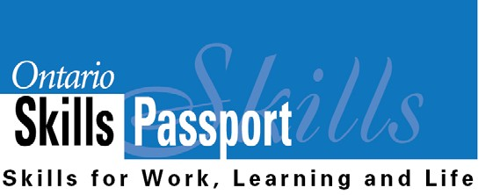

ontario.ca/skillspassport

Ontario Skills Passport Reflection
Worksheet

Name: Date: Volunteer Experience at School:

Who am I? | What Essential Skills and work habits did I develop and demonstrate?  What did I learn about myself from this experience?
What are my opportunities? | What other experiences can I pursue that can help me apply and further develop my Essential Skills and work habits?
Who do I want to become? | How do my Essential Skills and work habits prepare me for the types of occupations that I have identified in my goals?
What is my plan for achieving my goals? | Are there any Essential Skills and work habits that I need to further develop to achieve these goals?  What is my next step to further develop my Essential Skills and work habits?

Save this reflection in your “All About Me” portfolio.

ontario.ca/skillspassport

Connecting Essential Skills and
Work Habits to Guest Speakers

Guest Speaker Name and Occupation:

As you listen to the speaker, put a check mark beside the Essential Skills and Work Habits they indicate are important for their job.

OSP Icon Essential Skill OSP Icon Work Habit
 |  | Reading Text
 |  | Writing
 |  | Document Use
 |  | Computer Use
 |  | Oral Communication
 |  | Money Math
 | 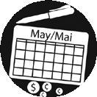 | Scheduling or Budgeting and Accounting
 | 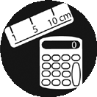 | Measurement and Calculation
 |  | Data Analysis
 | 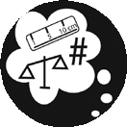 | Numerical Estimation
Job Task Planning
and Organizing
 |  | Decision Making
 |  | Problem Solving
 |  | Finding Information
 |  | Critical Thinking

 |  | Working Safely
 |  | Teamwork
 | 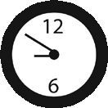 | Reliability
 |  | Organization
 |  | Working Independently
 |  | Initiative
 |  | Self-advocacy
 |  | Customer Service
 |  | Entrepreneurship

The Most Important Thing I Learned Was…

Occupation: Custodian (sample)

Identify (using a checkmark) which Essential Skills a custodian uses to complete the requirements of the job.

Essential Skill |  | For each Essential Skill, describe a sample task that  might be performed by a worker in this occupation.
Reading Text |  | Read cleaning product labels to understand how to use them.
Writing |  | Write inspection reports to describe problems and maintenance requirements for the supervisor’s review.
Document Use |  | Complete timesheet.
Computer Use
Oral Communication |  | Interact with supervisors to receive work assignments, discuss priorities and report problems.
Money Math
Scheduling or Budgeting and
Accounting
Measurement and Calculation
Data Analysis
Numerical Estimation |  | Estimate the correct volume of cleaning fluid which needs  to be added to a bucket of water.
Job Task Planning and Organizing
Decision Making |  | Decide how best to accomplish cleaning tasks in the allocated time.
Problem Solving |  | Deal with public pressure to use scent-free products  which reduce the likelihood of allergic reaction. In response to complaints, identify suitable and cost-effective alternative  products and monitor their practical effectiveness.
Finding Information |  | Consult Material Safety Data Sheets (MSDS) to find out a  product’s chemical composition and how to use it safely.
Critical Thinking

Essential Skills in Jobs

Occupation:

Identify (using a checkmark) which Essential Skills are used to complete the requirements of this job.

Essential Skill |  | For each Essential Skill, describe a sample task that  might be performed by a worker in this occupation.
Reading Text |  | .
Writing
Document Use
Computer Use
Oral Communication
Money Math
Scheduling or Budgeting and
Accounting
Measurement and Calculation
Data Analysis
Numerical Estimation
Job Task Planning and Organizing
Decision Making
Problem Solving
Finding Information
Critical Thinking

Name: Date:

Career:

Who am I? | I like this career because…  The Essential Skills I have that are needed for this career are…  The Work Habits I have that are needed for this career are…
What is my plan for achieving my goals? | The Essential Skills that I need to further develop for this career are…  The Work Habits that I need to further develop for this career are…
What are my opportunities? | What other experiences can I pursue that can help me apply and further develop my Essential Skills and work habits?

Save this reflection in your “All About Me” portfolio.

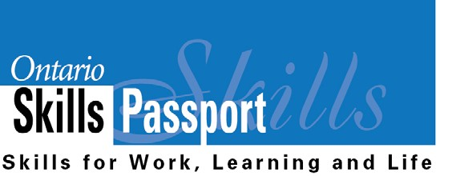
ontario.ca/skillspassport

Essential Skills and Work Habits
Progress Sheet

BELIEVE, ACHIEVE, SUCCEED

Name: Date:
TERM 1

I can use these Essential Skills and work habits:

I want to improve my use of these Essential Skills and work habits:

2 actions to help me accomplish my goal are:

TERM 2

I can use these Essential Skills and work habits:

I want to improve my use of these Essential Skills and work habits:

2 actions to help me accomplish my goal are:

Save this progress sheet in your “All About Me” portfolio.

ontario.ca/skillspassport

Copy and paste relevant OSP logos into student materials.
This can help students recognize that the Essential Skills and work habits they are developing and demonstrating in different learning activities are relevant and transferable to everyday life.

OSP Icon Essential Skill OSP Icon Work Habit
Working Safely
Teamwork
Reliability
Organization
Working Independently
Initiative
Self-advocacy
Customer Service
Entrepreneurship

 | Reading Text
 | Writing
 | Document Use
 | Computer Use
 | Oral Communication
 | Money Math
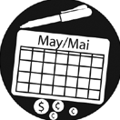 | Scheduling or Budgeting and Accounting
 | Measurement and Calculation
 | Data Analysis
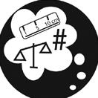 | Numerical Estimation
 | Job Task Planning and Organizing
 | Decision Making
 | Problem Solving
 | Finding Information
 | Critical Thinking

